1. Agenda:
   1. How to create Dynamic Stub by reading query parameter from HTTP Request.
2. 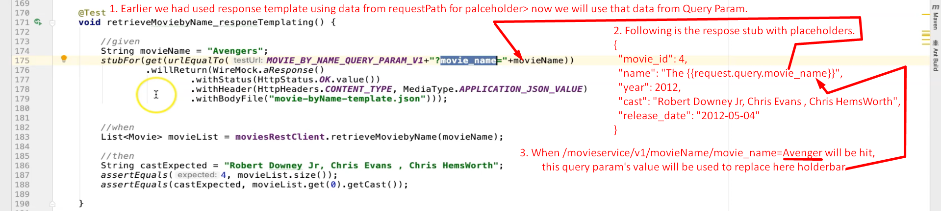
3. 